**Quality Improvement Study**

**Measuring Hand Hygiene Learning Outcomes**

**December 2012**

1. **Purpose of the Study**

The purpose of the study is to demonstrate that patients who receive medical services at any FAU campus clinic and who complete the Hand Hygiene pre-post assessment tools will be able to state one fact related to good hand hygiene discussed during a recent clinic visit.

An assessment tool (pre-test) which was pre-approved by the QMI Committee, will be distributed to 50 patients (40 Boca, 5 Davie and 5 Jupiter) before the scheduled appointment time, followed by an opportunity for education and discussion with the provider. An identical assessment tool (post-test) will then be distributed following the appointment in addition to a brochure (attached) to take home to reinforce the material reviewed during his/her appointment. See Hand Hygiene Assessment Tool below.

1. **Performance Goal**

90% of participants will receive a score of 80% or above on the post Hand Hygiene Assessment Tool.

1. **Data to be Collected**

Answers to the five questions on the pre- and post-tests of the Hand Hygiene Assessment Tool.

**Influenza Assessment Tool**

1. The Centers for Disease Control and Prevention says “Handwashing is the single most important means of preventing the spread of infection.” TRUE or FALSE.
2. Alcohol-based hand sanitizers are NOT effective in killing most common germs on the hands. TRUE or FALSE.
3. You need to wash your hands for a total of two minutes for handwashing to be effective. TRUE or FALSE.
4. To be effective, soap and hot water must be used for handwashing. TRUE or FALSE.
5. The American Medical Association and the Centers for Disease Control and Prevention recommend the use of antibacterial soaps for handwashing. TRUE or FALSE.
6. **Evidence of Data Collection**
   1. Due to having an extra copy of the assessment tool, 51 participants performed thepre-test and4 did not perform the post test, leaving 47 participants to survey.
   2. 44 out of 47 participants received a score of 80% or above on the post-test Hand Hygiene Assessment Tool.
7. **Analysis**

93.6% of the participants received a score of 80% or above on the post-test Hand Hygiene Assessment Tool.

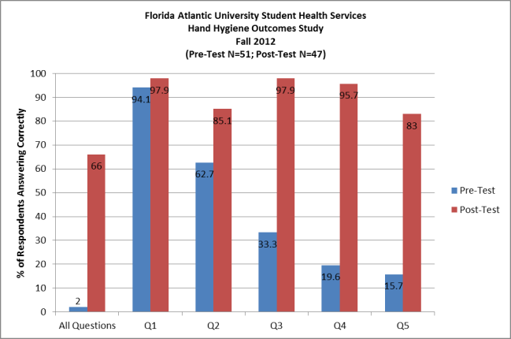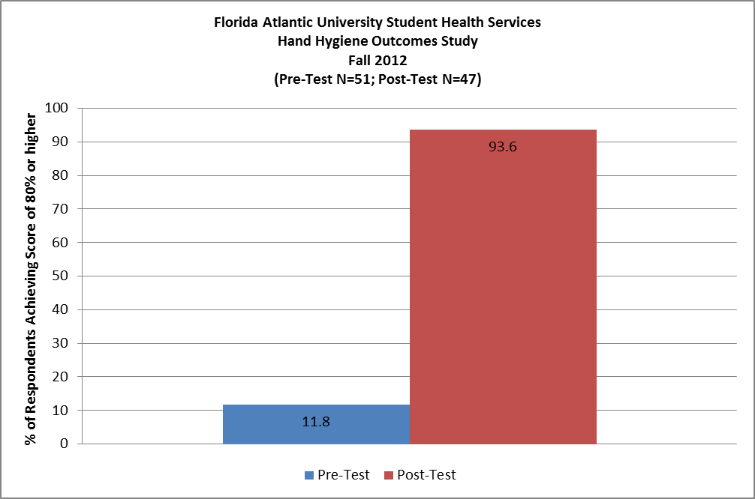

1. **Comparison of Current Performance vs. Goal**

Greater than 90% of participants received a score of 80% or above on the post-test Hand Hygiene Assessment Tool.

1. **Corrective Actions**

None indicated.

1. **Re-Measurement**

None indicated.

1. **Recommendations**

None indicated.

1. **Reporting and Education**

Results will be forwarded to the Executive Committee, the QMI Committee, the Provider Committee, SHAC and appropriate SHS Staff.

H:\Microsoft Word\General Documents\QMI Committee\QMI studies\Hand Hygiene Learning Outcomes Assessment Fall 2012\Hand Hygiene Learning Outcomes 12.12.docx